UML Assignment

1. Select one of the following system to draw package, component and deployment diagrams:
   1. Hospital System
   2. Back System
   3. Online Shopping System

Clarify what are architecture decisions reflected by your diagrams

Package Diagram

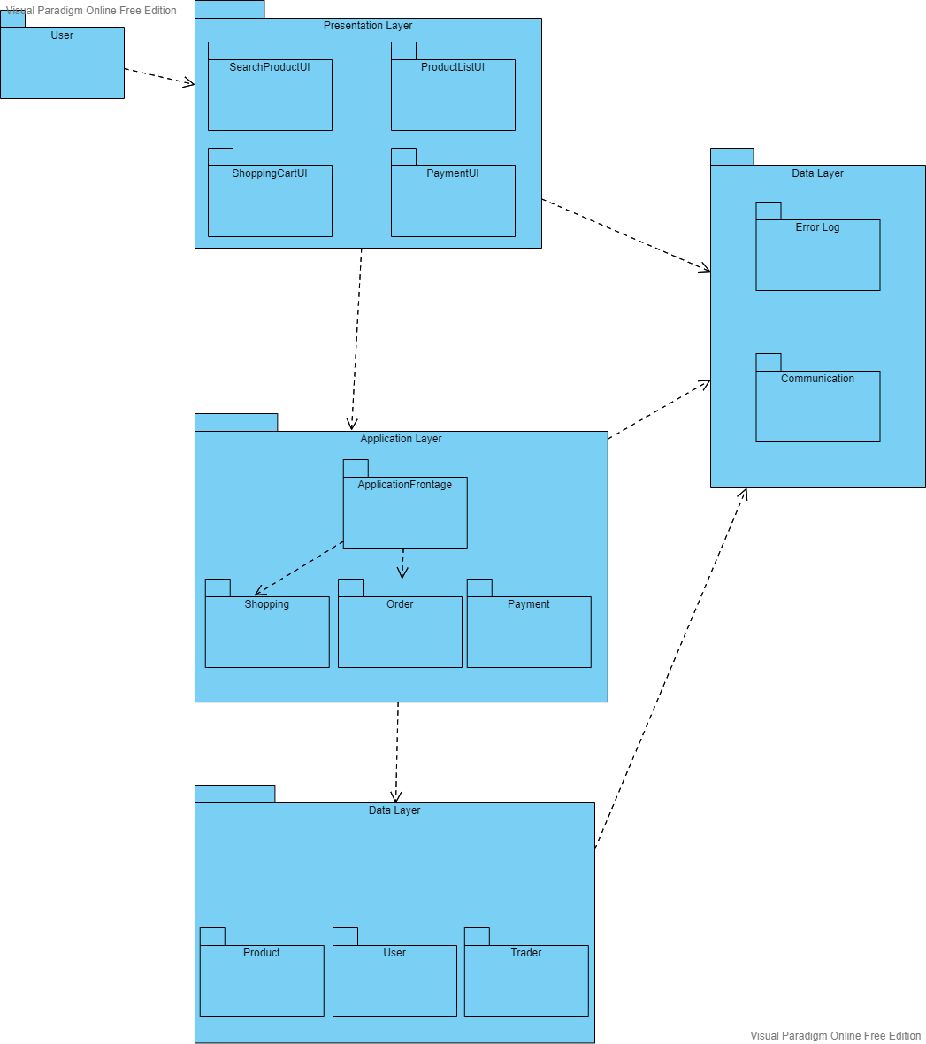

Component Diagram

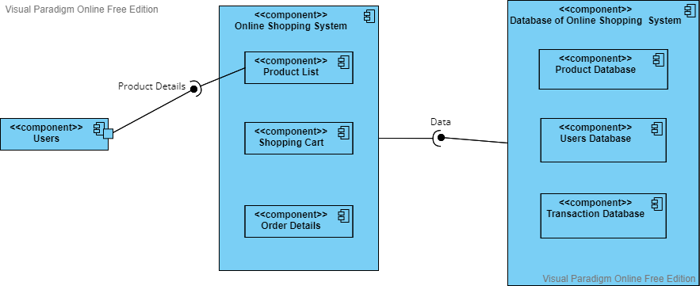

Deployment Diagram

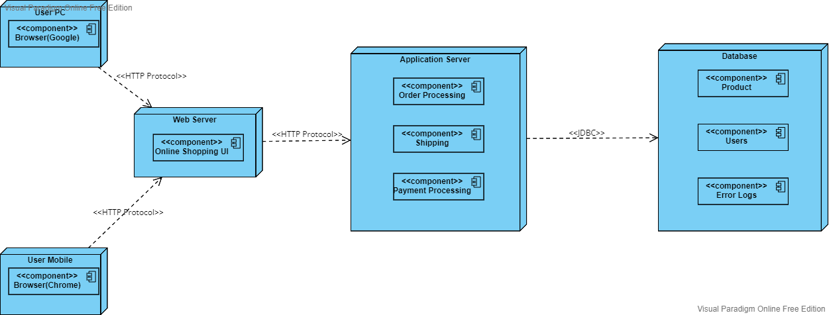

Actually, this online shopping system uses 3-tier architecture which consists of presentation layer, application layer and database layer. Each of the tier runs on its own architecture. Therefore, development of one tier will not affect the others, development of three tiers at the same time is allowed. Hence, this substantiated that the modifiability of this system is quite high.